**Batch:** B-4 **Roll No.:** 16010422234 **Name:** Chandana Ramesh Galgali

**______________________________________________________________________________**

**Code:**

**<!DOCTYPE html>**

**<html lang="en">**

**<head>**

**<meta charset="UTF-8">**

**<meta name="viewport" content="width=device-width, initial-scale=1.0">**

**<style>**

**body {**

**font-family: Arial, sans-serif;**

**display: flex;**

**justify-content: center;**

**align-items: center;**

**flex-direction: column;**

**min-height: 100vh;**

**margin: 0;**

**background-color: #f0f0f0;**

**}**

**form {**

**justify-content: center;**

**align-items: center;**

**margin-top: 20px;**

**padding: 20px;**

**background: #ffffff;**

**box-shadow: 0 0 10px rgba(0, 0, 0, 0.1);**

**border-radius: 8px;**

**}**

**h1 {**

**color: #333;**

**text-align: center;**

**}**

**fieldset {**

**border: 1px solid #ccc;**

**margin-top: 10px;**

**padding: 10px;**

**border-radius: 5px;**

**}**

**legend {**

**font-weight: bold;**

**}**

**label {**

**margin: 10px 0 5px;**

**}**

**input[type="text"],**

**input[type="password"],**

**input[type="date"],**

**input[type="tel"],**

**input[type="email"],**

**input[type="range"],**

**input[type="url"],**

**select,**

**textarea {**

**width: fit-content;**

**padding: 10px;**

**margin-bottom: 15px;**

**border: 1px solid #ccc;**

**border-radius: 4px;**

**}**

**input[type="submit"],**

**input[type="reset"] {**

**cursor: pointer;**

**font-weight: bold;**

**padding: 10px 15px;**

**border: none;**

**border-radius: 4px;**

**margin-right: 10px;**

**background-color: #007bff;**

**color: white;**

**}**

**input[type="reset"] {**

**background-color: #6c757d;**

**}**

**input[type="submit"]:hover,**

**input[type="reset"]:hover {**

**opacity: 0.9;**

**}**

**</style>**

**</head>**

**<body>**

**<h1>Registration Form</h1>**

**<form method="post" action="">**

**<fieldset><legend>Login Details:</legend>**

**<label for="username">Username:</label>**

**<input type="text" id="username" name="username" autofocus>**

**<label for="pwd">Password:</label>**

**<input type="password" id="pwd" name="pwd">**

**</fieldset><br>**

**<fieldset><legend>Personal Details:</legend>**

**<label for="fname">First name:</label>**

**<input type="text" id="fname" name="fname" required placeholder="Enter your first name" minlength="2" maxlength="100" pattern="[A-Za-z]+">**

**<label for="mname">Middle name:</label>**

**<input type="text" id="mname" name="mname" placeholder="Enter your middle name" minlength="2" maxlength="100" pattern="[A-Za-z]+">**

**<label for="lname">Last name:</label>**

**<input type="text" id="lname" name="lname" required placeholder="Enter your last name" minlength="2" maxlength="100" pattern="[A-Za-z]+"><br>**

**<label for="gender">Gender:</label>**

**<select id="gender" name="gender" required>**

**<option value="" disabled selected>Select your gender</option>**

**<option value="male">Male</option>**

**<option value="female">Female</option>**

**<option value="other">Other</option>**

**</select>**

**<label for="dob">DOB:</label>**

**<input type="date" id="dob" name="dob" required min="1900-01-01" max="2010-12-31">**

**<label for="age">Age:</label>**

**<input type="range" id="age" name="age" min="0" max="100" step="1" value="18" title="Adjust age">**

**<label for="eyecolor">Eye Color:</label>**

**<input type="color" id="eyecolor" name="eyecolor" value="#ffffff" title="Choose your favorite color">**

**</fieldset><br>**

**<fieldset><legend>Contact Details:</legend>**

**<label for="phone">Mobile number:</label>**

**<input type="tel" id="phone" name="phone" required placeholder="9870776977" pattern="[0-9]{10}" maxlength="10" title="Ten digit mobile number">**

**<label for="email">Email:</label>**

**<input type="email" id="email" name="email" required placeholder="username@gmail.com" pattern="[a-z0-9._%+-]+@[a-z0-9.-]+\.[a-z]{2,}$" title="Email address">**

**</fieldset><br>**

**<fieldset><legend>Professional Details:</legend>**

**<p>Choose your profession:**

**<input type="radio" id="student" name="profession" value="Student">**

**<label for="student">Student</label>**

**<input type="radio" id="working" name="profession" value="Working">**

**<label for="working">Working</label>**

**<input type="radio" id="retired" name="profession" value="Retired">**

**<label for="retired">Retired</label></p>**

**<label for="linkedin">LinkedIn Profile:</label>**

**<input type="url" id="linkedin" name="linkedin" placeholder="https://example.com" pattern="https?://.*" title="Include http:// or https://">**

**</fieldset><br>**

**<fieldset><legend>Residential Details:</legend>**

**<p>Enter your Address:</p>**

**<textarea name="message" style="width:400px; height:150px;"></textarea><br>**

**<label for="country">Country:</label>**

**<input type="text" id="country" name="country" required placeholder="Country" >**

**<label for="state">State/Region:</label>**

**<input type="text" id="state" name="state" required placeholder="State/Region">**

**<label for="pincode">Pincode/Zipcode:</label>**

**<input type="text" id="pincode" name="pincode" pattern="\d{6}" required placeholder="Enter your pincode/zipcode">**

**</fieldset><br>**

**<fieldset><legend>Identity Proof Details:</legend>**

**<p>Select the documents uploaded for verification:**

**<input type="checkbox" id="aadharcard" name="aadharcard" value="Aadhar Card">**

**<label for="aadharcard"> Aadhar Card</label>**

**<input type="checkbox" id="passport" name="passport" value="Passport">**

**<label for="passport"> Passport</label>**

**<input type="checkbox" id="drivinglicense" name="drivinglicense" value="Driving License">**

**<label for="drivinglicense"> Driving License</label></p>**

**<label for="myfile">Select the verification documents:</label>**

**<input type="file" id="myfile" name="myfile" multiple accept=".pdf,.doc,.jpg" title="Upload documents">**

**</fieldset><br>**

**<input type="submit" onclick="alert('Submitted!')" value="Submit">**

**<input type="reset" value="Reset">**

**</form>**

**</body>**

**</html>**

**______________________________________________________________________________**

**Results:**

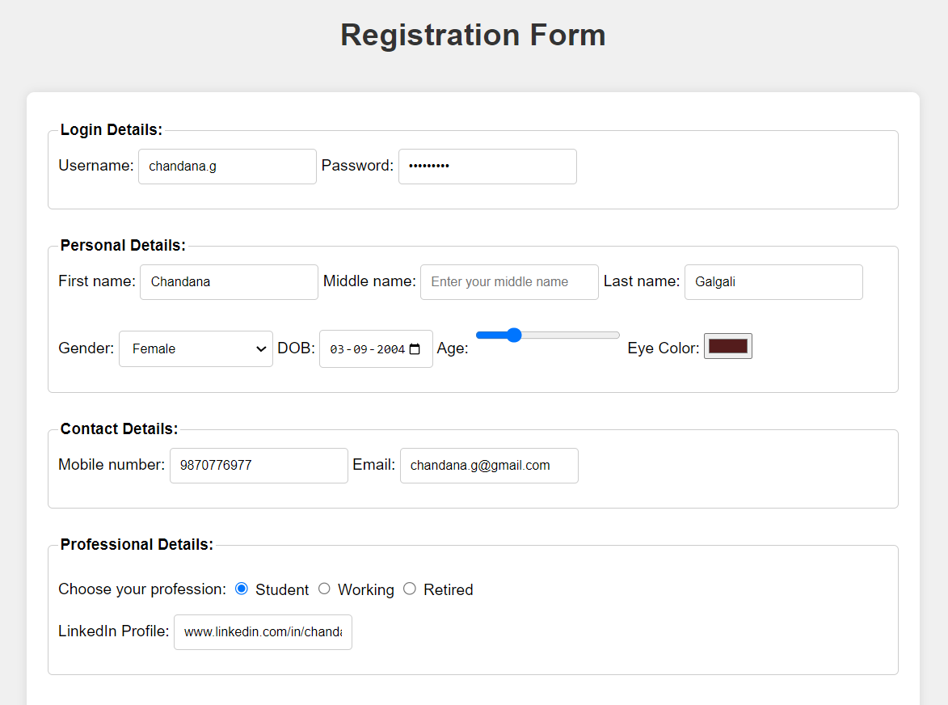

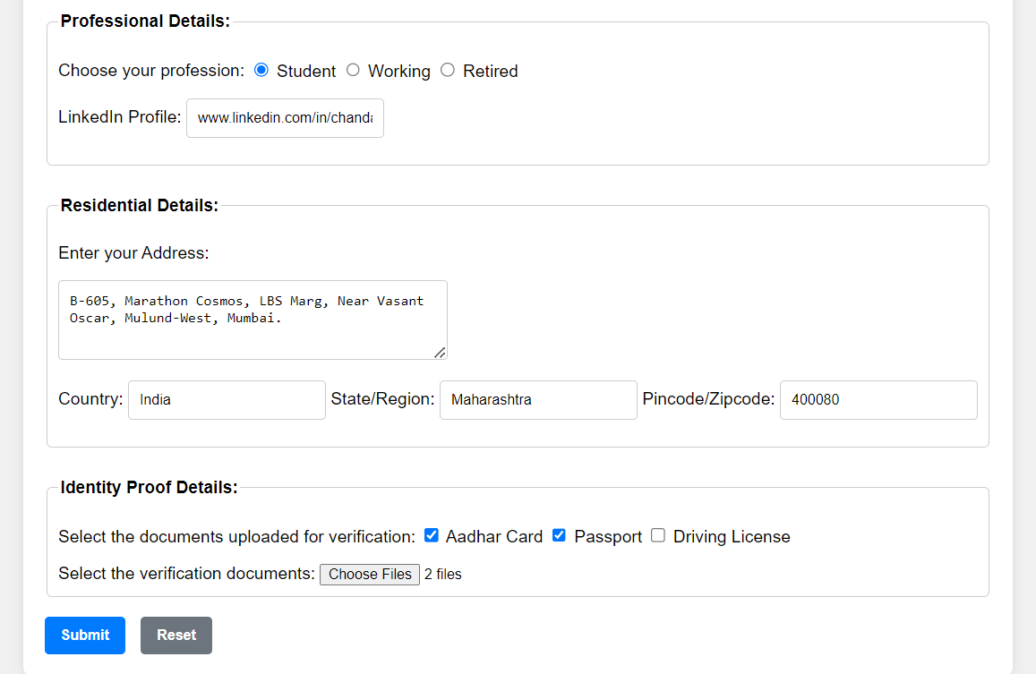

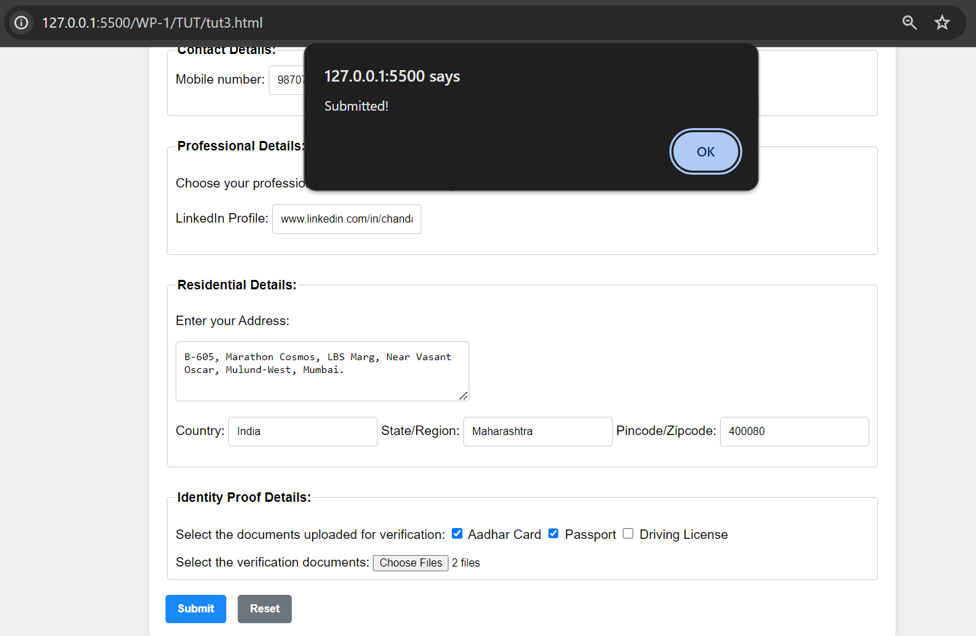

**______________________________________________________________________________**

**Outcomes:** Create Web pages using HTML 5 and CSS.

**______________________________________________________________________________**

**Conclusion: (Conclusion to be based on the outcomes achieved)**

This experiment with designing forms using HTML5 input elements and attributes successfully demonstrated the power of HTML5 in creating efficient, user-friendly, and accessible web forms. It highlighted the importance of utilizing the right input types and attributes to enhance the user experience, streamline data collection, and ensure compatibility across a wide range of devices and browsers.

**______________________________________________________________________________**